
University of Engineering & Management, Kolkata
STUDENT DETAILS
ANTORI DAS
SA
AAAA

antoridas8@gmail.com
Email ID
Full Name

The Canteen Queue

The Canteen Queue

ASSIGNMENT DETAILS
Problem Title
SUBMISSION CHECKLIST
Institute of Engineering and Management, Newtown Campus Department of Computer Applications

ASSIGNMENT SUBMISSION — TOP SHEET
Technical Class Assessment — April 2026
Database Management Systems & Java with JDBC | MCA Programme

Roll Number | 14(12025006015014) | Registration No. | 304202500600014

Section | A | Semester | 2

Programme | MCA | Academic Year | 2025-2026

Subject | Java – DBMS Assignment | Set Number | 3

Language Used | DBMS & Core Java | Database Used | MySQL 8.0.44

Submission Date | 10TH APRIL 2026 | Total Pages | 12

#  1 | Item  Printed Java Source Code (DBConnection.java) | Included ( / ) | Pages / Remarks
2 | Printed Java Source Code (Main.java)
3 | Printed SQL Schema File (schema.sql)

4
Screenshot(s) of Program Execution (printed)

5 Problem Statement (this top sheet attached)
ANTORI DAS (10.04.2026)

Faculty Signature & Date
Student Signature & Date
I hereby declare that this assignment is my own original work. I have not copied from any other student or used any unauthorised sources. I understand that plagiarism will result in zero marks and disciplinary action.
DECLARATION

University of Engineering & Management, Kolkata | Department of Computer Applications | Technical Class Assessment — April 2026


University of Engineering & Management, Kolkata Institute of Engineering and Management, Newtown Campus Department of Computer Applications
CREATE TABLE menu_items (
item id INT PRIMARY KEY AUTO INCREMENT,
item_name VARCHAR(100), price DECIMAL(6,2)

Degree: MCA
Due Date:
Stream: MCA
Set No: 3

The Canteen Queue
[Domain: Campus Life j

Language | Core Java (Console Application)
Database | MySQL
Connectivity | JDBC (Java Database Connectivity)

The Story
“If only we knew /?ovr many students want rice and how many want noodles — before 12 o'clock.”

The college canteen at IEM Newtown sees a lunch-hour rush every day. Students crowd the counter, orders get mixed up, and the cook has no idea how many plates of each dish to prepare. Food is either wasted or runs out too early.
Your task is to build a Canteen Order Management System using Java and MySQL.

Your Task
Build a Canteen Order Management System as a Java console application using JDBC and MySQL.

Your system must allow:
- Add a new menu item with name and price
- Place an order for a student (student name, item, quantity)
- Mark an order as served once food is handed over
- Display total revenue and most ordered item of the day

Database Schema
Create the following table(s) in MySQL:

CREATE TABLE orders (
order_id INT PRIMARY KEY AUTO_INCREMENT,
student VARCHAR(100),
item id INT,
quantity INT DEFAULT 1,
ordered at DATETIME DEFAULT NOW(), served BOOLEAN DEFAULT FALSE,
FOREIGN KEY (item id) REFERENCES menu items(item_id)

Required Features

Feature | Implementation Hint
Add Menu Item | INSERT into menu_items with name and price
Place Order | INSERT into orders with student, item id, quantity
Mark Served | UPDATE orders SET served=TRUE WHERE order id=?
Daily Report | SUM(price”quantity) for revenue; ORDER BY COUNT(*) for top item

Constraints
- Use Core Java only — no Spring, Hibernate, or web frameworks
- Connect to MySQL using JDBC (no JPA / ORM)
- All operations must be menu-driven via console
- No GUI required — Scanner-based input is sufficient
- Handle SQL exceptions with try-catch blocks
- Use PreparedStatement for all SQL queries

Sample Interaction
C
e ystem =====
1
:
Add Mene :t:
e
M l ORd
Served
i
EntE choice: 4
Today's Revenue: Rs 2340.00
Most Ordered: Chicken Rice (47 plates)

Submission Checklist
- DBConnection.java (JDBC connection class)
- Main.java (menu-driven main program)
- SQL file: schema.sql (CREATE TABLE statements)
- screenshot.png (terminal output showing at least 2 features working)

I “A database is not just data. It is the memory of your application. Make it reliable.”

Src|MAIN.JAVA

package src;

import java.sql.*;
import java.util.Scanner;

public class Main {
static Scanner sc = new Scanner(System.in);

public static void main(String[] args) {

while (true) {
System.out.println("\n===== Canteen System =====");
System.out.println("1. Add Menu Item");
System.out.println("2. Place Order");
System.out.println("3. Mark Order Served");
System.out.println("4. Daily Report");
System.out.println("5. Exit");

System.out.print("Enter choice: ");
int choice = sc.nextInt();

switch (choice) {
case 1:
addMenuItem();
break;
case 2:
placeOrder();
break;
case 3:
markServed();
break;
case 4:
dailyReport();
break;
case 5:
System.exit(0);
}
}
}

public static void addMenuItem() {
try (Connection con = DBConnection.getConnection()) {

sc.nextLine();
System.out.print("Enter item name: ");
String name = sc.nextLine();

System.out.print("Enter price: ");
double price = sc.nextDouble();

String sql = "INSERT INTO menu_items (item_name, price) VALUES (?, ?)";
PreparedStatement ps = con.prepareStatement(sql);
ps.setString(1, name);
ps.setDouble(2, price);

ps.executeUpdate();
System.out.println("Item Added!");

} catch (Exception e) {
e.printStackTrace();
}
}

public static void placeOrder() {
try (Connection con = DBConnection.getConnection()) {

sc.nextLine();
System.out.print("Enter student name: ");
String student = sc.nextLine();

Statement st = con.createStatement();
ResultSet rs = st.executeQuery("SELECT * FROM menu_items");

System.out.println("Menu:");
while (rs.next()) {
System.out.println(rs.getInt(1) + " " + rs.getString(2) + " Rs" + rs.getDouble(3));
}

System.out.print("Enter item ID: ");
int id = sc.nextInt();

System.out.print("Enter quantity: ");
int qty = sc.nextInt();

String sql = "INSERT INTO orders (student, item_id, quantity) VALUES (?, ?, ?)";
PreparedStatement ps = con.prepareStatement(sql);
ps.setString(1, student);
ps.setInt(2, id);
ps.setInt(3, qty);

ps.executeUpdate();
System.out.println("Order Placed!");

} catch (Exception e) {
e.printStackTrace();
}
}

public static void markServed() {
try (Connection con = DBConnection.getConnection()) {

System.out.print("Enter Order ID: ");
int id = sc.nextInt();

String sql = "UPDATE orders SET served = TRUE WHERE order_id=?";
PreparedStatement ps = con.prepareStatement(sql);
ps.setInt(1, id);

int rows = ps.executeUpdate();

if (rows > 0)
System.out.println("Order Served!");
else
System.out.println("Not Found!");

} catch (Exception e) {
e.printStackTrace();
}
}

public static void dailyReport() {
try (Connection con = DBConnection.getConnection()) {

String rev = "SELECT SUM(m.price * o.quantity) FROM orders o JOIN menu_items m ON o.item_id = m.item_id";
ResultSet rs1 = con.createStatement().executeQuery(rev);

if (rs1.next())
System.out.println("Revenue: Rs " + rs1.getDouble(1));

String top = "SELECT m.item_name, SUM(o.quantity) total FROM orders o JOIN menu_items m ON o.item_id=m.item_id GROUP BY m.item_name ORDER BY total DESC LIMIT 1";
ResultSet rs2 = con.createStatement().executeQuery(top);

if (rs2.next())
System.out.println("Top Item: " + rs2.getString(1) + " (" + rs2.getInt(2) + ")");

} catch (Exception e) {
e.printStackTrace();
}
}
}

Src|DBConnection.java

package src;

import java.sql.*;

public class DBConnection {

static final String URL = "jdbc:mysql://localhost:3306/canteen_db?useSSL=false&allowPublicKeyRetrieval=true&serverTimezone=UTC";
static final String USER = "testuser";
static final String PASSWORD = "1234";

public static Connection getConnection() {
try {
return DriverManager.getConnection(URL, USER, PASSWORD);
} catch (SQLException e) {
System.out.println("Database Connection Failed!");
e.printStackTrace();
return null;
}
}
}

Sql|schema.sql

CREATE DATABASE canteen_db;

USE canteen_db;

CREATE TABLE menu_items (
item_id INT PRIMARY KEY AUTO_INCREMENT,
item_name VARCHAR(100),
price DECIMAL(6,2)
);

CREATE TABLE orders (
order_id INT PRIMARY KEY AUTO_INCREMENT,
student VARCHAR(100),
item_id INT,
quantity INT DEFAULT 1,
ordered_at DATETIME DEFAULT NOW(),
served BOOLEAN DEFAULT FALSE,
FOREIGN KEY (item_id) REFERENCES menu_items(item_id)
);

screenshots

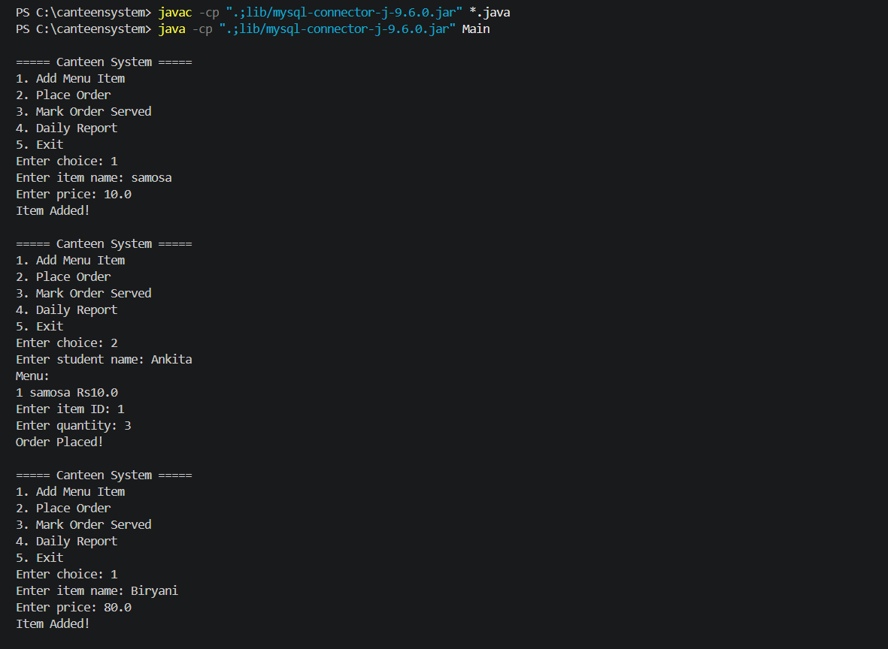

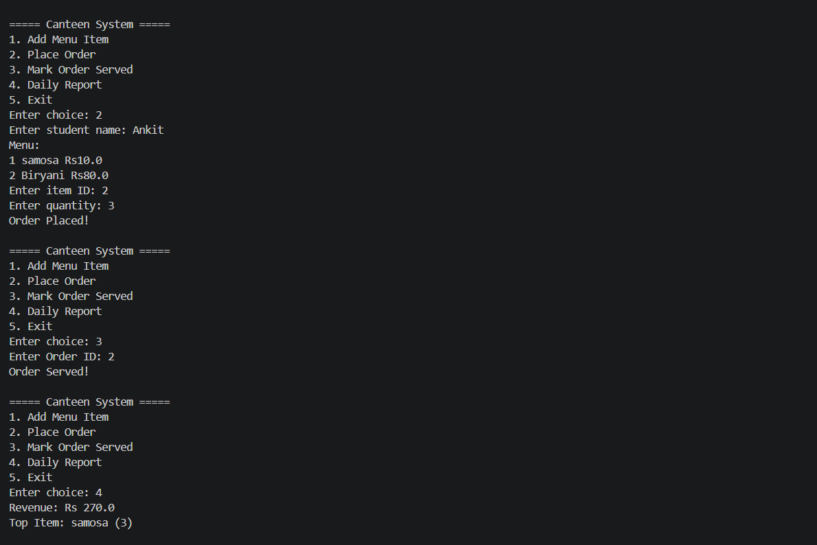

FILE STRUCTURE

